SAMPLE Release of Rights to Intellectual Property
with Conditions of Use
[Date]
I certify that the image below is my property, and grant the California Department of Fish and Wildlife (CDFW) permission to use the image as follows:
- Reproduction in CDFW print publication, “The Dog Fish of Canine Bay,” for an unlimited time.
- Publication on CDFW website at up to a width of 1200 pixels, from January 1, 2016 through December 31, 2060.
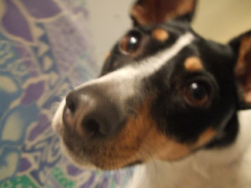

[Signature Here]
Edith Citizen
321 My Place
Anytown, CA 95555
(916) 123-4567
edith@gmail.com

