December 2016

water management companion plan
Photo Credit:
Left:
Lake Shasta, California
Date: 19 July 2010
Photographer: brianscotland0 via pixabay

Right:
Monarch Butterfly
Date: 17 March 2006
Photographer: Armon via Wiki Commons

Prepared by Blue Earth Consultants, LLC
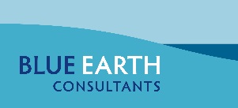
October 2016

Disclaimer:
Although we have made every effort to ensure that the information contained in this report accurately reflects SWAP 2015 companion plan development team discussions shared through web-based platforms, e-mails, and phone calls, Blue Earth Consultants, LLC makes no guarantee of the completeness and accuracy of information provided by all project sources. SWAP 2015 and associated companion plans are non-regulatory documents. The information shared is not legally binding nor does it reflect a change in the laws guiding wildlife and ecosystem conservation in the state. In addition, mention of organizations or entities in this report as potential partners does not indicate a willingness and/or commitment on behalf of these organizations or entities to partner, fund, or provide support for implementation of this plan or SWAP 2015.
The consultant team developed companion plans for multiple audiences, both with and without jurisdictional authority for implementing strategies and conservation activities described in SWAP 2015 and associated companion plans. These audiences include but are not limited to the California Department of Fish and Wildlife leadership team and staff; the California Fish and Game Commission; cooperating state, federal, and local government agencies and organizations; California Tribes and tribal governments; and various partners (such as non-governmental organizations, academic research institutions, and citizen scientists).
Table of Contents
Acronyms and Abbreviations i
1. Introduction 1
1.1 SWAP 2015 Statewide Goals 2
1.1 SWAP 2015 Companion Plans 2
Need for Partnerships 2
Companion Plan Purpose and Sector Selection 2
Companion Plan Development 3
Companion Plan Content 4
2. Water Management Sector 5
2.1 Water Management in California 5
2.2 Current Water Management and Conservation in California 8
3. Common Themes across Nine Sectors 10
3.1 Climate Change-related Issues 11
3.2 Integrated Regional Planning 11
4. Commonly Prioritized Pressures and Strategy Categories across Sectors 12
Pressures across Sectors 13
4.1 Strategy Categories across Sectors 14
5. Water Management Priority Pressures and Strategy Categories 15
5.1 Priority Pressures 15
5.2 Priority Strategy Categories 15
6. Collaboration Opportunities for Joint Priorities 17
Alignment Opportunities and Potential Resources 17
7. Evaluating Implementation Efforts 20
8. Desired Outcomes 21
9. Next Steps 22
10. Acknowledgements 24
Appendices 25
Appendix A: References 25
Appendix B: Plans, Strategies, and Documents Identified by the Development Team 26
Appendix C: Companion Plan Development Team Members and Affiliations 31
Appendix D: Water Use Fact Sheets (DWR, 2014) 32
Appendix E: Potential Partners for Collaboration 35
Appendix F: Potential Financial Resources 38
Appendix G: Companion Plan Management Team 39
Appendix H. Glossary 40

Text Boxes
Text Box 1: What is a State Wildlife Action Plan? 1
Text Box 2: Definitions Important to SWAP 2015 1
Text Box 3: Companion Plan Sectors 2
Text Box 4: Where does California’s Water Go? 5
Text Box 5: Examples of Collaborative Conservation Efforts 10
Text Box 6: Additional Pressures and Strategies for Future Consideration 17

Figures
Figure 1: Aligning SWAP 2015 and Partner Priorities 3
Figure 2: How Water is Used in California 7

Tables
Table 1: SWAP 2015 Pressures 14
Table 2: SWAP 2015 Conservation Strategy Categories 15
Table 3: Collaborative Opportunities by Strategy Category 18

Acronyms and Abbreviations
AB Assembly Bill
ACWA Association of California Water Agencies
AFWA Association of Fish and Wildlife Agencies
Blue Earth Blue Earth Consultants, LLC
CalEPA California Environmental Protection Agency
CASGEM California Statewide Groundwater Elevation Monitoring
CBC California Biodiversity Council
CDFA California Department of Food and Agriculture
CDFW California Department of Fish and Wildlife
CDWR California Department of Water Resources
CEC California Energy Commission
Ch. Chapter
CNRA California Natural Resources Agency
CVP Central Valley Project
Delta Conservancy Sacramento-San Joaquin Conservancy
DOGGR Division of Oil, Gas and Geothermal Resources
DRECP Desert Renewable Energy Conservation Plan
EQIP Environmental Quality Incentives Program
GAMA Groundwater Ambient Monitoring and Assessment
HCP Habitat Conservation Plan
IRWMP Integrated Regional Water Management Plan
KEA Key Ecological Attribute
LAFCO Local Agency Formation Commission for San Bernardino County
LCC Landscape Conservation Cooperative
MAF Million Acre-Feet
NCCP Natural Community Conservation Plan
NGO Non-Governmental Organization
NRCS Natural Resources Conservation Service
NOAA National Oceanic and Atmospheric Administration
RAMP Regional Advance Mitigation Planning
RCD Resource Conservation District
RWQCB Regional Water Quality Control Board
SGC Strategic Growth Council
SGCN Species of Greatest Conservation Need
SNC Sierra Nevada Conservancy
SWAMP Surface Water Ambient Monitoring Program
SWAP State Wildlife Action Plan
SWG State and Tribal Wildlife Grants
SWP State Water Project
SWRCB State Water Resources Control Board
TMDL Total Maximum Daily Load
TNC The Nature Conservancy
USACE U.S. Army Corps of Engineers
USEPA United States Environmental Protection Agency
USFS U.S. Forest Service
USFWS U.S. Fish and Wildlife Service
WCB Wildlife Conservation Board
WIP Watershed Improvement Program

Introduction
Text Box 1: What is a State Wildlife Action Plan?
In 2000, Congress enacted the State and Tribal Wildlife Grants (SWG) program to support state programs that broadly benefit wildlife and habitats, but particularly “Species of Greatest Conservation Need” (SGCN) as defined by individual states. Congress mandated each state and territory to develop a SWAP that outlined a comprehensive wildlife conservation strategy to receive federal funds through the SWG program. From 2005 through 2014, CDFW received approximately $37 million through the SWG program, matched with approximately $19 million in state government support for wildlife conservation activities. The SWG program requires SWAP updates at least every 10 years. CDFW prepared and submitted SWAP 2015, the first comprehensive update of the California SWAP 2005, to the U.S. Fish and Wildlife Service (USFWS). The update allows CDFW to expand and improve the recommended conservation activities addressed in the original plan by integrating new knowledge acquired since 2005 (CDFW 2015).
The California State Wildlife Action Plan 2015 Update (SWAP 2015; see Text Box 1) provides a vision and a framework for conserving California’s diverse natural heritage. SWAP 2015 also calls for the development of a collaborative framework to sustainably manage ecosystems across the state in balance with human uses of natural resources. To address the need for a collaborative framework, California Department of Fish and Wildlife (CDFW), Blue Earth Consultants, LLC (Blue Earth), and partner agencies and organizations undertook the preparation of companion plans for SWAP 2015. While this document reports on the progress made thus far on collaboration, the intent is to set a stage for achieving the state’s conservation priorities through continued partnerships and by mutually managing and conserving natural and cultural resources. Text Box 2 highlights important definitions for SWAP 2015 and the companion plan process.
Conservation Target: An element of biodiversity at a project site, which can be a species, habitat/ecological system, or ecological process on which a project has chosen to focus.
Goal: A formal statement detailing a desired outcome of a conservation project, such as a desired future status of a target. The scope of a goal is to improve or maintain key ecological attributes (defined below).
Key Ecological Attribute (KEA): An aspect of a target’s biology or ecology that, if present, defines a healthy target and, if missing or altered, would lead to outright loss or extreme degradation of the target over time.
Objective: A formal statement detailing a desired outcome of a conservation project, such as reducing the negative impacts of a critical pressure (defined below). The scope of an objective is broader than that of a goal because it may address positive impacts not related to ecological entities (such as getting better ecological data or developing conservation plans) that would be important for the project. The set of objectives developed for a conservation project are intended, as a whole, to lead to the achievement of a goal or goals, that is, improvements of key ecological attributes.
Pressure: An anthropogenic (human-induced) or natural driver that could result in changing the ecological conditions of the target. Pressures can be positive or negative depending on intensity, timing, and duration. Negative or positive, the influence of a pressure to the target is likely to be significant.
Target: Same as conservation target defined above.
Species of Greatest Conservation Need (SGCN): All state and federally listed and candidate species, species for which there is a conservation concern, or species identified as being vulnerable to climate change as defined in SWAP 2015.
Strategy: A group of actions with a common focus that work together to reduce pressures, capitalize on opportunities, or restore natural systems. A set of strategies identified under a project are intended, as a whole, to achieve goals, objectives, and other key results addressed under the project.
Stress: A degraded ecological condition of a target that resulted directly or indirectly from negative impacts of pressures (e.g., habitat fragmentation).

Text Box 2: Definitions Important to SWAP 2015
(CDFW 2015)

SWAP 2015 Statewide Goals
SWAP 2015 has three statewide conservation goals and 12 sub-goals under which individual regional goals are organized (CDFW 2015). These statewide goals set the context for SWAP 2015 and the companion plans.
Goal 1 - Abundance and Richness: Maintain and increase ecosystem and native species distributions in California while sustaining and enhancing species abundance and richness.
Goal 2 - Enhance Ecosystem Conditions: Maintain and improve ecological conditions vital for sustaining ecosystems in California.
Goal 3 - Enhance Ecosystem Functions and Processes: Maintain and improve ecosystem functions and processes vital for sustaining ecosystems in California.

SWAP 2015 Companion Plans

Need for Partnerships
The state of California supports tremendous biodiversity. However, the state also has a large and growing human population and faces many challenges, such as climate change, that affect biodiversity and natural resources in general. To balance growing human activities with conservation needs for sustaining the state’s ecosystems, collaboratively managing and conserving fragile natural resources is a necessity. As many desirable conservation actions identified under SWAP 2015 are beyond CDFW’s jurisdiction, the Department determined that more-detailed coordination plans are needed in line with and beyond the recommendations presented in SWAP 2015. Called “companion plans,” these sector-specific plans (see Text Box 3) were created collaboratively with partners and will be instrumental in implementing SWAP 2015 (See Appendix C).
Text Box 3: Companion Plan Sectors
- Agriculture
- Consumptive and Recreational Uses
- Energy Development
- Forests and Rangelands
- Land Use Planning
- Marine Resources
- Transportation Planning
- Tribal Lands
- Water Management

Companion Plan Purpose and Sector Selection
Companion plans present shared priorities identified among SWAP 2015 and partners involved in the companion plan development. Figure 1 illustrates how, through collaboration with partner organizations, shared priorities come together in the companion plans and become elevated as high implementation priorities for SWAP 2015.
The companion plans respond to feedback from many sources, including CDFW staff and partners involved in natural resources management and conservation. This includes the California Biodiversity Council (CBC), under which a resolution to promote interagency alignment within the state was signed in 2013. The companion plans are also aligned with the National Fish, Wildlife, and Plants Climate Adaptation Strategy (U. S. Fish and Wildlife Service [USFWS] 2012), which emphasizes increased partner engagement as a best practice in climate change adaptation. Developing the companion plans also directly helps CDFW comply with recently enacted legislation, which states that CDFW shall “seek to create, foster, and actively participate in effective partnerships and collaborations with other agencies and stakeholders to achieve shared goals and to better integrate fish and wildlife resource conservation and management with the natural resource management responsibilities of other agencies” (CDFW 2012).
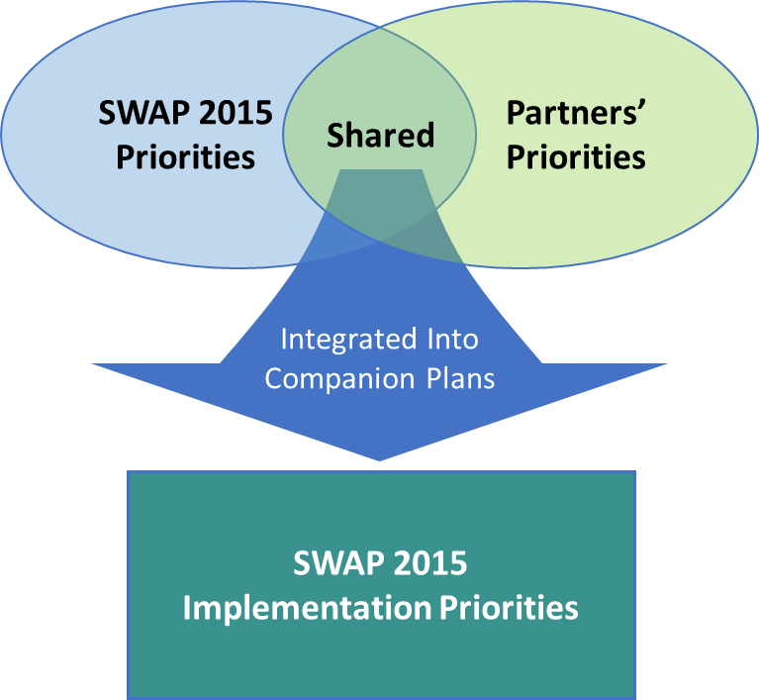
CDFW selected sector categories based on the department’s needs as well as the themes identified in other existing plans, including the 2009 California Climate Adaptation Strategy (California Natural Resources Agency [CNRA] 2009), the 2014 Safeguarding California Plan (CNRA 2014), The President’s Climate Action Plan (Executive Office of the President 2015), and the National Fish, Wildlife, and Plants Climate Adaptation Strategy (USFWS 2012).
Figure 1: Aligning SWAP 2015 and Partner Priorities

Companion Plan Development
Because the companion plans focused on teamwork during their development, they inherently help set a stage for implementing SWAP 2015 through future collaborations. Together, SWAP 2015 and the associated companion plans describe the context and strategic direction of integrated planning and management efforts that are crucial for sustaining California’s ecosystems. The SWAP 2015 companion plan management team, composed of CDFW and Blue Earth staff, provided general direction to the companion plan development teams to develop each sector plan. (see Appendix G). To form sector teams, CDFW sought statewide representation of public and private partners with topic expertise and who were heavily involved in natural resource conservation and management (see Appendix E).
Beginning in early 2015, Blue Earth facilitated a series of four web-based collaboration meetings for each sector. A kickoff meeting provided development teams with an overview of SWAP 2015 and the companion plan development process, followed by three sector-specific meetings. During these sector meetings, participants discussed their ongoing and potential future efforts that would benefit wildlife and habitat conservation in the state. The development teams and CDFW then identified shared priorities, as well as collaboration opportunities for achieving those mutual interests. Two internal drafts of the companion plans were reviewed by the development teams prior to the public release of the third draft in the fall of 2015. The final nine companion plans were published incorporating responses to public comments.

Companion Plan Content
Each companion plan addresses the following components:
- SWAP 2015 overview
- Companion plans overview—approach, purpose, development process, and content
- Sector overview
- Common themes across sectors
- Common priority pressures and strategies across sectors
- Priority pressures and strategies for the sector
- Potential collaboration activities
- Potential partners and resources
- Evaluating implementation
- Desired outcomes
- Next steps

Water Management Sector

Water Management in California
California covers nearly 156,000 square miles of land, has more than 1,100 miles of coastline, and is home to over 39 million people (U.S. Census Bureau 2015). California receives 200 million acre-feet (MAF) of water on average each year from precipitation and regional imports from Oregon, the Colorado River, and Mexico (California Department of Water Resources [CDWR] 2014). Native vegetation, evaporation into the atmosphere, agricultural crops and wetlands, and flows to other states or the ocean use 50–60% of this water (CDWR 2014). The remaining water is dedicated to urban and agricultural uses, environmental restoration, and storage for future use (see Text Box 4).
- California’s water supports three main sectors: cities and communities, agriculture, and environment.
- On average, the proportion of water used by each sector is 10% cities and communities, 40% agriculture, and 50% environment.
- This statewide ratio varies widely depending on whether a year is wet or dry. In wet years, the proportion that serves environmental purposes can be 60% or more, while in dry years that proportion drops to roughly one-third.
- Water often serves double duty: Water allocated for one purpose is often reused for other purposes downstream. Water flowing into the Delta to repel saltwater intrusion often serves a dual purpose by also helping native fish.

For more information about water use in California, see the factsheets provided in Appendix D.
Text Box 4: Where does California’s Water Go?
The means to distribute water throughout California to serve these different uses is complex. The unique delivery system of the California State Water Project (SWP), constructed and operated by CDWR, provides water for 25 million residents and 750,000 acres of irrigated agricultural land (CDWR 2008). The main purpose of the SWP is to store and distribute water to 29 urban and agricultural water suppliers in California, where 70% goes to urban users and 30% goes to agricultural users (CDWR 2008). The U.S. Bureau of Reclamation’s Central Valley Project (CVP) also helps to address California’s water demands. Spanning approximately 400 miles between Redding and Bakersfield, the CVP is one of the world’s largest water storage and transport systems (Bureau of Reclamation 2013). The CVP consists of 20 dams and reservoirs, 11 power plants, and several hundred miles of major canals (Bureau of Reclamation 2013). The CVP provides about 5 MAF for farms; 600,000 acre-feet of water for municipal and industrial uses; 800,000 acre-feet per year to fish, wildlife, and habitat enhancement; and over 400,000 acre-feet to state and federal wildlife refuges and wetlands (Bureau of Reclamation 2013).
(CDWR, 2015b)
Within this mosaic of storage, distribution and usage, water availability for environmental needs can fluctuate significantly depending on precipitation, and varies considerably throughout California (PPIC 2010). Water distribution ranges between 9% and 13% for urban uses, 31% and 48% for agricultural uses, and 40% and 60% for environmental water in wet to dry years (CDWR 2014). In 2010, an “average” water year, the figures were 49% for environmental use, 41% for agricultural use, and 10% for urban use. Average total water usage for the 10-year period between 2001 and 2010 shows environmental water at 46%, agriculture at 43%, and urban use at 11% in the state, totaling about 82 MAF (CDWR 2014).
Figure 2 shows comparative water usage between different sectors under specific water years, with amounts for each use (in MAF) provided in the embedded table (CDWR 2014). As 2006 was a wet year, environmental water accounted for 60% of the total 108 MAF of the applied water use in the state. In contrast, environmental use decreased to 39% of the total water distribution in 2007, a dry year. The Table shows that water allocations for urban and managed wetlands changed minimally, and agricultural and instream flow requirements fluctuated by 4 MAF and 2 MAF respectively, from wet to dry years. Minimum Delta outflow requirements, however, fluctuated by nearly 6 MAF and wild and scenic rivers by about 25 MAF, from wet to dry years. Although the percentages from wet to dry years may indicate a shift in water allocated to each use (such as agricultural), actual use in MAF did not change more than 25% (urban and agricultural use not more than 10%) with the exception of minimum requirements for Delta outflow and wild and scenic rivers (CDWR 2014).

Figure 2: How Water is Used in California
 |  | Applied Water Use
 |  | 2006 (Wet) |  | 2007 (Dry)
Water Use | Definition | % | MAF | % | MAF
Urban | Water for urban purposes, including residential, commercial, institutional, and industrial. | 9% | 9.5 | 13% | 9.6
Agriculture | Water for irrigated agriculture including multi-cropping. | 31% | 33.3 | 48% | 36.9
Managed Wetlands | Water for managed wetland areas. | 2% | 1.6 | 2% | 1.6
Minimum Instream Flow Req’ts | Water within natural waterways as specified in an agreement, water rights permit, court order, FERC license, etc. | 8% | 8.5 | 8% | 6.5
Minimum Required Delta Outflow* | Freshwater outflow from the Sacramento-San Joaquin Delta required by law to protect the beneficial uses within the Delta from the incursion of saline water. | 9% | 10.1 | 6% | 4.5
Wild and Scenic Rivers | Over 2,000 miles of river systems are designated wild, scenic, and recreational under the 1968 National Wild and Scenic Rivers Act and 1972 California Wild and Scenic Rivers Act. | 41% | 44.8 | 23% | 18.1
* Total Delta Outflow is higher than Required Delta Outflow: 2006=41.3 maf and 2007=6.2 maf (pie chart includes required Delta Outflow only).
Quantities reflect surface and groundwater supplies. (CDWR, 2014)

Groundwater is another critical resource for meeting California’s diverse water demands. There are 515 groundwater basins that the California Statewide Groundwater Elevation Monitoring (CASGEM) Basin Prioritization Program has categorized and prioritized to help identify, evaluate, and determine the need for additional groundwater-level monitoring (CDWR 2015a). These basins contributed an estimated 38% of California’s 2005–2010 average annual total water supply and contribute as much as 45% during dry years (CDWR 2014-2015c). The SWRCB Groundwater Ambient Monitoring and Assessment (GAMA) program was established in 2000 and expanded by Assembly Bill [AB] 599 (Groundwater Quality Monitoring Act of 2001) with the goals of improving statewide groundwater monitoring and increasing the availability of groundwater quality information to the public (State Water Resources Control Board [SWRCB] 2015b).
Several existing and planned efforts seek to address and balance California’s current and future water demands. The most significant effort is the SWRCB, through its Division of Water Rights, placing an increased emphasis on protecting fish, wildlife, and recreation opportunities through integrating both public trust and appropriative right systems for surface water allocations (SWRCB 2015a).

Current Water Management and Conservation in California
Many state water management partners have incorporated strategies to conserve California’s natural and wildlife resources in their programs and plans. For example, the Governor’s Water Action Plan was developed to meet three objectives: reliable water supplies, the restoration of important species and habitat, and increased resiliency and sustainability of water resources. The plan addresses pressing water issues through priority actions, including protection and restoration of important ecosystems. Examples include giving priority to key mountain meadow habitats and managing headwaters for multiple benefits, as well as refuges like the Pacific Flyway for migratory birds (CNRA, California Department of Food and Agriculture [CDFA], and California Environmental Protection Agency [CalEPA] 2014). The Water Action Plan highlights 10 essential actions to accomplish these goals:
- make conservation a California way of life;
- increase regional self-reliance and integrated water management across all levels of government;
- achieve the co-equal goals for the Delta of providing a more reliable water supply for California and protecting, restoring, and enhancing the Delta ecosystem;
- protect and restore important ecosystems;
- manage and prepare for dry periods;
- expand water storage capacity and improve groundwater management;
- provide safe water for all communities;
- increase flood protection;
- increase operational and regulatory efficiency; and
- identify sustainable and integrated financing opportunities.
To help implement the Water Action Plan, the California Water Plan Update 2013 includes a roadmap with a suite of related actions/objectives and resource management strategies that advance the 10 essential actions identified. To protect and restore important ecosystems, the plan’s supporting strategies include agricultural lands stewardship, forest management, land use planning and management, ecosystem restoration, and watershed management (CDWR 2014). Furthermore, the Sacramento–San Joaquin Delta Conservancy (Delta Conservancy) contributes to the conservation of California’s natural and wildlife resources through their mission of "working collaboratively and in coordination with local communities.” In doing so, the Delta Conservancy will lead efforts to “protect, enhance, and restore the Delta’s economy, agriculture and working landscapes and environment for the benefit of the Delta region and its local communities, and the citizens of California” (Delta Conservancy 2012). The Conservancy’s goals also include leading efforts to protect, enhance, and restore ecosystems in partnership with other entities and stakeholders (Delta Conservancy 2012). Another example of conservation efforts is the Central Valley Flood Management Planning Program’s System Conservation Strategy goal to promote ecosystem function, recovery and stability of native species populations, and overall community diversity (CDWR 2015a). These are just a few examples of efforts in the water management sector that support conservation and restoration of California’s natural and wildlife resources.
Improving habitat conservation through better water management is a state priority. The $7.545 billion Proposition 1 water bond, approved overwhelmingly by California voters in 2014, will provide a significant source of funding for water projects and programs at a crucial time. Key funding areas include regional water reliability, public benefit of water storage capacity (e.g., agriculture and urban users, water quality objectives for wildlife), water recycling, groundwater sustainability, safe drinking water, and watersheds and flood management (Association of California Water Agencies [ACWA] 2014). Furthermore, the Sustainable Groundwater Management Act “allows local agencies to customize groundwater sustainability plans to their regional economic and environmental needs” (California Groundwater 2015). In addition, CDFW received funding from the USFWS SWG in 2004 for the California Coastal Watershed Planning and Assessment, which supported multi-disciplinary, large-scale watershed assessments along the length of California’s coast to help improve freshwater habitat and support increased salmonid populations (CDFW 2014). SWAP 2015 includes a chapter on anadromous fish and highlights core principles, including water conservation, to identify and implement water management strategies designed to provide sufficient flow quality and quantity to meet fish and habitat needs (CDFW 2015). By continuing to enhance water management, CDFW and other partners can work together to meet California’s current and future water needs while also protecting and conserving the state’s natural and wildlife resources.

Text Box 5: Examples of Collaborative Conservation Efforts
There are numerous collaborative conservation management efforts found in California. Below are three such examples related to water management. The partners addressed in each description are indicated in bold.
- Maintaining Migratory Bird Habitat: In 2014, the California Rice Commission and The Nature Conservancy (TNC) partnered on the BirdReturns pilot program, which provided farmers in the Sacramento Valley with incentives for maintaining flooded fields as habitat for migrating shorebirds. TNC initiated the program to ensure that birds migrating through the Central Valley would have sufficient wetland habitat for wintering. Through collaboration with eBird, a citizen science project that collects data on bird sightings, TNC identified rice farms in bird migration paths, and worked with the California Rice Commission to provide rice farmers with incentives (compensation for irrigation costs) to maintain flooding in their fields during migration season (Robbins 2014). The flooded fields created “pop-up habitats” for migrating birds. During February and March 2014, over 40 rice farms participated in the pilot and provided nearly 10,000 acres of habitat for shorebirds (TNC California 2014).
- Restoring the Sierra Nevada Watershed: In March 2015, the Sierra Nevada Conservancy (SNC) partnered with U.S. Forest Service (USFS) to launch the Sierra Nevada Watershed Improvement Program (WIP), a collaborative effort to restore and improve ecosystem health of the Sierra Nevada Watershed through a suite of restoration and conservation activities. The WIP will work to restore streams and meadows, preserve working landscapes, restore forest health, and improve socio-economic conditions in the region (USFS 2015). The program will begin by focusing on forest restoration activities to increase the resilience of forests to catastrophic wildfires. SNC and USFS are working with state, federal, tribal, and local agencies, as well as other interested stakeholders, to implement activities that will occur under the WIP.
- Collaborating to Restore the Delta: The CNRA is partnering with the Delta Conservancy on California EcoRestore, a new initiative to create a coordinated approach to conservation and restoration of the San Joaquin Delta ecosystem (CNRA 2015). California EcoRestore, which evolved from the Bay-Delta Conservation Plan, will include a variety of projects designed to increase resilience of Delta ecosystems to climate change, improve habitat for threatened species, and protect and restore ecosystems, with the goal of restoring 30,000 acres of Delta habitat. The Delta Conservancy, in collaboration with local governments, will lead regional and local planning processes to identify priority restoration projects. EcoRestore will also work to engage non-governmental organizations (NGOs), academia, and other interested stakeholders to address stressors (e.g., invasive species, climate change) threatening Delta ecosystems (CNRA 2015).

Common Themes across Nine Sectors
Equally important to discussion topics unique to each sector are the common themes across all sectors. This section summarizes the two major overarching themes discussed through the course of developing the nine companion plans: climate change and integrated regional planning.

Climate Change-related Issues
Climate change continues to be one of the major pressures forcing us to examine the relationship between modern society and nature. Describing climate science, however, has been difficult due to its inherent complexity. Because of this and other factors, our society has not been able to fully embrace the seriousness of the implications of climate change. In the most recent analyses, the global average temperature is projected to increase in the range of 0.3–4.8°C (0.5–8.6°F) by 2100, and in California, the increase is projected to be 1.5°C (2.7°F) by 2050 and 2.3–4.8°C (4.1–8.6°F) by 2100 (IPCC 2014; CNRA 2014).
The effects of climate change are already present. Global sea level rise over the past century has exceeded the mean rate of increase during the previous two millennia, and the earth’s surface temperature over each of the last three decades has been successively warmer than any previous decade since 1850. The evidence of these observed climate change impacts is manifested the strongest and most comprehensively in natural systems where many species of terrestrial, freshwater and marine organisms have shifted their geographic ranges, migration patterns, abundances, and life cycle activities in response to ongoing climate change (IPCC 2014).
As climate conditions are inextricably linked to the welfare of environments and societies, even the most conservatively projected increase in global mean temperatures would trigger significant changes to socio-economic and ecosystem conditions. Food production, energy and water development, and preparation and response to catastrophic events are examples of human systems that would be negatively affected by climate change. Pressures and stresses to ecosystems identified in SWAP 2015 will likely increase in magnitude and severity through the compounding effects of climate change (SWAP 2015).
Accordingly, the potential far-reaching effects on California’s natural resources induced or exacerbated by climate change were a common concern among sectors, and cross-sector collaboration was considered critical for ecosystem adaptation while avoiding disasters.
Two key discussion points amongst sectors were to strategically assess the state’s climate change vulnerabilities and implement adaptation actions. These actions included, but were not limited to: establishing a well-connected reserve system to increase ecosystem integrity (e.g. habitat resilience and mobility); incorporating climate change related factors (e.g. carbon sequestration, habitat shifts and sea level rise) into natural resource management; improving regulations to reduce greenhouse gas emissions; developing research guidelines to comprehensively evaluate climate change effects; and raising awareness of climate change.

Integrated Regional Planning
California presents a landscape that is ecologically, socioeconomically, and politically intricate. The current status of the state’s ecosystems reflects not only the interactions between biological and abiotic components, but also among ecosystems and diverse human activities that are further controlled by mandates imposed on regulated activities.
The concept of integrated regional planning arises from the realization that addressing only one aspect of a complicated human/nature system is not sustainable. Paraphrased from the definition in the California Water Plan, integrated regional planning is an approach to prepare for effective management, including conservation activities, while concurrently achieving social, environmental, and economic objectives to deliver multiple benefits across the region and jurisdictional boundaries (CDWR, 2014). Expected outcomes of adopting an integrated regional planning approach include; maximizing limited resources to meet diverse demands, receiving broader support for natural resource conservation, and sustaining and improving ecosystem conditions, both for intrinsic and resource values.
Integrated regional planning begins with accepting diverse priorities and values articulated by the stakeholders of a region. With this mutual understanding, attempts are made, often through intense negotiations, to integrate various activities associated with multiple interests occurring in the region. Expected tasks under integrated regional planning include: identifying conflicting or redundant activities occurring in a region, minimizing redundant activities by aligning similar efforts, streamlining and integrating needed processes across different priorities, and collaborating and complementing efforts to effectively achieve mutual and/or diverse interests. As an example, integrated regional planning could result in zoning a region and limiting activities within each zone to avoid or reduce incompatible activities occurring in the region, or deferring timing to reduce negative consequences of interactive activities occurring in a region. In sum, integrated regional planning requires trust, open-mindedness, transparency, patience, strategic thinking, and collaboration among partners who seek to use the same or similar resources from different perspectives.
Establishing a framework for integrated regional planning was considered as one of the state’s top priorities across sectors. Related topics included: preparing, approving, and implementing regional and landscape-level conservation plans; systematically pursuing necessary resources to implement conservation strategies; coordinating effective partnerships; adapting to emerging issues; and reviewing and revising the plans. Several existing plans were recognized as ongoing integrated regional planning efforts: Natural Community Conservation Plans (NCCPs), Habitat Conservation Plans (HCPs), Habitat Connectivity Planning for Fish and Wildlife (CDFW 2015), the Master Plan for Marine Protected Areas, individual species management plans, and SWAP 2015 and related endeavors, including this companion plan.
SWAP 2015, Chapter 7 describes implementation and integration opportunities, and identifies where partners can engage in cooperative implementation. Such opportunities include programs under various state and federal agencies such as Regional Advance Mitigation Planning (RAMP) by Caltrans and DWR; California Water Plan, California Water Action Plan, and the Central Valley Flood System Conservation Strategy by DWR; Fire and Resource Assessment Program by CALFIRE; and federal programs under regulations such as the Central Valley Project Improvement Act, and the National Forest Management Act (CDFW 2015).

Commonly Prioritized Pressures and Strategy Categories across Sectors
SWAP 2015 adopted the Open Standards for the Practice of Conservation (Conservation Measures Partnership 2013), a conservation planning framework, and applied the process to select actions needed to conserve focal ecological components (conservation targets). The process started with examining the status of targets by identifying and evaluating their key ecological attributes, factors influencing their compromised conditions (stresses), and the sources of these stresses (pressures). Based on the situational analysis, conservation strategies (sets of actions) were selected for each target, either to improve the conditions of key ecological attributes, or to reduce the negative impacts from the stresses and pressures (CDFW 2015).

Pressures across Sectors
A pressure, as defined in SWAP 2015, is “an anthropogenic (human-induced) or natural driver that could result in impacts to the target (i.e., ecosystem) by changing the ecological conditions”. Pressures can have either positive or negative effects depending on their intensity, timing, and duration, but they are all recognized to have strong influences on the well-being of ecosystems. Table 1 below lists the 29 standard pressures addressed under SWAP 2015.
Table 1: SWAP 2015 Pressures
- Agricultural and forestry effluents | - Livestock, farming, and ranching
- Air-borne pollutants | - Logging and wood harvesting
- Annual and perennial non-timber crops | - Marine and freshwater aquaculture
- Catastrophic geological events¹ | - Military activities
- Climate change¹ | - Mining and quarrying
- Commercial and industrial areas² | - Other ecosystem modifications⁶
- Dams and water management/use | - Parasites/pathogens/diseases
- Fire and fire suppression | - Recreational activities
- Fishing and harvesting aquatic resources | - Renewable energy
- Garbage and solid waste | - Roads and railroads
- Household sewage and urban waste water ^{3,4} | - Shipping lanes⁷
- Housing and urban areas² | - Tourism and recreation areas
- Industrial and military effluents^{4, 5} | - Utility and service lines
- Introduced genetic material | - Wood and pulp plantations
- Invasive plants/animals
Pressures include the following:
- Volcano eruption, earthquake, tsunami, avalanche, landslide, and subsidence
- Shoreline development
- Urban runoff (e.g., landscape watering)
- Point discharges
- Hazardous spills
- Modification of mouth/channels; ocean/estuary water diversion/control; and artificial structures
(CDFW 2015)
- Ballast water

Strategy Categories across Sectors
SWAP 2015 outlines 11 categories of conservation strategies (Table 2) under which regional strategies are organized, similar to the manner in which the regional goals are tiered under the statewide conservation goals (CDFW 2015). These regional strategies grouped in various categories are meant to work synergistically to achieve the statewide goals and priorities.
Table 2: SWAP 2015 Conservation Strategy Categories
- Data Collection and Analysis | - Law and Policy
- Direct Management | - Management Planning
- Economic Incentives | - Partner Engagement
- Environmental Review | - Outreach and Education
- Land Acquisition, Easement, and Lease | - Training and Technical Assistance
- Land Use Planning | (CDFW 2015)
The three most common priority strategy categories across the nine sectors were Data Collection and Analysis (7 sectors prioritized this strategy), Management Planning (7 sectors), and Partner Engagement (5 sectors). The strategy categories identified as most relevant to the water management sector are described in Section 5.2 below.

Water Management Priority Pressures and Strategy Categories
As described in SWAP 2015, a pressure such as dams and water management/use, can affect biodiversity and natural resources in the state. Although key challenges exist, these seemingly negative aspects of pressures present opportunities for improving ecological health through collaborative conservation work.
For the purpose of developing companion plans, CDFW went through the pressures and strategy categories that were selected for various conservation targets under SWAP 2015 (CDFW 2015). Those elements considered relevant to each sector were collected from the document and prioritized by importance to the sector. Section 5.1 and 5.2 provide the results of this prioritization, and Text Box 5 lists pressures and strategies considered important but not included in this plan for future consideration.

Priority Pressures
Dams and water management/use – The management of water resources to meet water (stream and off-stream use) and power supply needs and to accommodate communities and agricultural production results in numerous pressures on rivers, wetlands, estuaries, and aquifers. This includes changing natural water flow patterns either deliberately or as a result of other activities, such as dam construction, dam operations, sediment control, salt regime change, wetland filling for mosquito control, levees and dike construction, surface water diversion, groundwater pumping, channelization, artificial lake creation, and illegal diversions.

Priority Strategy Categories
The top six strategy categories selected for this sector are the following (in alphabetical order): data collection and analysis, direct management, law and policy, land acquisition, easement, and lease, management planning, and partner engagement. These categories are described below.
Data Collection and Analysis (long-term) – Data collection and analysis is the utilization of robust data and thorough analysis to inform and facilitate more effective implementation of conservation strategies under other categories. Example strategies include conducting research on groundwater, improving data availability across programs and agencies, and conducting data analysis to directly inform resource management and regulatory decisions.
Direct Management (short-term) – Direct management is the participation in and implementation of activities that support stewardship of habitats and natural processes to maintain, enhance, and restore species population and ecological functions/conditions. Example strategies include improving fish passage, managing barriers on water movement, managing water flows/use, and restoring natural flows.
Law and Policy (short- and long-term) – Law and policy is the development, revision, guidance, and implementation of legislation, regulations, policy, and voluntary standards to improve conservation stewardship of species and habitats. Example strategies include advocating for effective law enforcement, strengthening alignment of policies across government agencies, supporting legislative actions, and writing permits to improve habitat.
Land Acquisition, Easement, and Lease (short-term) – Land acquisition, easement, and lease are types of transactions and agreements that help set aside or obtain land or water rights, which support conservation of the land, water, and/or habitat that species depend upon. Example strategies include acquiring water rights and purchasing land and/or acquiring easements through negotiation with willing sellers.
Management Planning (long-term) – Management planning is the development of management plans or processes for species, habitats, and natural processes/conditions that will lead to implementation of more effective conservation strategies. Example strategies include integrating resource management activities and providing input on project planning and decision-making processes.
Partner Engagement (long-term) – Partner engagement is the process for engaging and developing collaboration among state and federal agencies, Tribes and tribal communities, NGOs, private landowners, and other partners to achieve shared conservation objectives and enhance coordination across jurisdictions and areas of interest. Example strategies include establishing collaborative partnerships and establishing/developing co-management partnerships.

Text Box 6: Additional Pressures and Strategies for Future Consideration
Pressures
- Land use
- Population growth
Strategies
- Improve management planning and direct management implementation by increasing achievement of water management, water sustainability, hatchery management, and pollution control objectives.
- Develop strategies to address habitat and migratory pathway (aquatic and terrestrial) impacts from water transportation and diversion including operation and development of fish catching devices and maintenance of fisheries below dams.
- Develop approaches to address non-point source pollution controls (e.g., strategies for sediment, nutrients, and mercury).
- Improve permitting and licensing processes by incorporating considerations of water and habitat impacts in decision-making.
- Improve use and implementation of promulgated rules and legislation including Total Maximum Daily Loads (TMDLs) to promote water quality improvements.

Collaboration Opportunities for Joint Priorities
Conservation programs in California are managed by diverse partners, including state and federal agencies, local governments, and NGOs. Because SWAP 2015 is a comprehensive conservation plan, integrating their work into SWAP is crucial for impactful conservation outcomes for the state (SWAP 2015 Chapter 7). While the full array of relevant efforts is too extensive to list here, potential alignment opportunities were identified. Conservation activities considered most relevant to each prioritized strategy category (as described in Section 5.2) are summarized in Table 3. Potential partners and financial resources for implementing these conservation activities are listed in the Appendix E and F. Together, Table 3 and Appendix D and E summarize the key findings for this sector.

Alignment Opportunities and Potential Resources
Table 3 highlights conservation activities by the strategy categories that the team considered important for collaboration, and which could be implemented over the next 5–10 years. While some activities are applicable across many spatial scales and jurisdictions, they are assigned only to the most relevant scale and jurisdiction. The information in Table 3 is not comprehensive, and does not obligate any organization to fund or provide support for strategy implementation.

Table 3: Collaborative Opportunities by Strategy Category
Data Collection and Analysis
Potential Activities
Statewide
- Advance integration of data management/data exchange
- Build distributed network of common spatial datasets
Regional
- Adopt resolution on strategic integrated regional conservation and development planning
Local/Site-specific
- Conduct fact assessments
- Conduct reporting by permittees as required by mitigation/Monitoring and Reporting Programs under the regulation of permitting actions or site cleanups
- Lead adaptation efforts in each sector
- Make databases available to public, citizen monitoring groups, and watershed stewardship organizations
- Monitor data collection efforts (e.g., the Delta)
- Outline primary risks of climate change vulnerabilities
- Prioritize financial and political support for data sharing
- Utilize existing databases and data visualization tools (e.g., DataBasin, EcoAtlas) for conservation planning efforts
Direct Management
Potential Activities
Statewide
- Raise awareness on flood protection efforts from other agencies to refine flood system management
Regional
- Contribute to basin planning by focusing on water quality objectives to protect aquatic life and wildlife beneficial uses (e.g., warm and cold water and estuarine habitats)
Local/Site-specific
- Adopt instream flow standards to support fisheries and habitats
- Contribute to implementation of riparian restoration (e.g. mitigation for permits/in lieu fees)
- Control point and non-point sources to ensure compliance with water quality objectives
- Engage the agriculture industry in contributing to improved water quality and climate solutions
- Establish simplified permitting process for implementation of small-scale, voluntary habitat restoration projects
- Focus on long-term license or relicense of hydroelectric projects
- Guide cap-and-trade investments in agriculture to achieve other environmental, health and economic benefits
- Implement wetland and riparian area protection policies
- Integrate research, education and technical assistance, and financial incentives to support agricultural producers
- Manage water flows/use and restore natural flows
- Plan groundwater management
- Reset flow objectives as needed
- Update plans (e.g., Bay Delta upgrade to septic systems through small community grants plan)
- Write permits to improve habitat (e.g., rare water bodies such as desert vernal pool areas)
Land Acquisition, Easement, and Lease
Potential Activities
Local/Site-specific
- Amend marsh agreements to restore wetlands
- Develop easement strategies with multiple objectives
- Focus on agricultural land stewardship strategies
- Improve water management through habitat restoration and levees
- Lease water rights in critical habitat areas
- Participate in ongoing wetland restoration programs (e.g., Suisun Marsh)
- Purchase land with senior water rights or directly purchase water rights
- Work with local landowners on species conservation
Law and Policy
Potential Conservation Activities
Statewide
- Adopt wetland and riparian area protection policies
- Improve conservation planning alignment on policies and regulations between government agencies
- Improve greenhouse gas goals by looking at natural infrastructure functions and opportunities to analyze executive orders
Local/Site-specific
- Adopt water quality standards that support fish, wildlife, habitats, and ecosystems uses of water, including in-stream flow standards
- Identify beneficial uses in wetland and riparian areas that have to be protected in water quality and water rights actions
- Take actions for land acquisition where appropriate and add ecosystem values in planning
Management Planning
Potential Conservation Activities
Regional
- Include consistent regional-scale methods for planning and conservation assessments
- Integrate water management approach with environmental stewardship
Local/Site-specific
- Address reservoir health and drinking water source issues
- Encourage low-impact development
- Filter salts, nitrogen, and other dissolved solids from groundwater
- Focus on waste discharge requirements (e.g., 401, 404)
- Monitor mitigation concurrent with construction
- Keep storm water on site and maintain open space between structures
- Recommend and target floodplain guidance
- Use de-salters for groundwater basins
- Utilize wetland and riparian area protection policies
Partner Engagement
Potential Conservation Activities
Statewide
- Engender collaboration between organizations so that each considers the needs of other organizations in the collection and assessment of data, rather than the requirements of individual organizational mandates
Regional
- Develop integrated water management plans with natural resource stewardship components
- Engage multiple partners at the regional scale
- Include variety of public and private stakeholders in communications and partnerships
Local/Site-specific
- Broaden watershed focus by integrating working groups
- Engage tribal groups and landowners in projects to understand land values to benefit water quality
- Manage healthy watersheds to create combined framework for engagement and evaluation
- Provide collaboration on water quality and ecosystem health
- Encourage groups to come together to develop water management plans and water budgets to show relative sources/uses and sustainability plans

Evaluating Implementation Efforts
Implementing SWAP 2015 and its nine companion plans is a complex undertaking. This section (and SWAP 2015 Chapter 8) emphasizes the importance of adaptive management based on performance monitoring and evaluation during the implementation stage.
SWAP 2015 sets a stage for adaptive management by developing the plan based on the Open Standards for the Practices of Conservation. SWAP 2015 implementation will be monitored over time in concert with other conservation activities conducted by CDFW and partners. SWAP 2015 recognizes three types of monitoring:
- status monitoring, which tracks conditions of species, ecosystems, and other conservation factors (including negative impacts to ecosystems) through time;
- effectiveness monitoring, which determines if conservation strategies are having
their intended results and identifies ways to improve actions that are less effective for adaptive management; and
- effects monitoring, which addresses if and how the target conditions are being
influenced by strategy implementation.
Monitoring and evaluating SWAP 2015 implementation are critical steps to demonstrate and account for the overall progress and success achieved by the plan. By incorporating lessons learned through monitoring conservation activities and evaluating for future actions, CDFW and partners have opportunities to improve performance and adapt emerging needs that were not previously considered. For stakeholders including decision-makers, partners, and funders, the resulting data would be useful for not only understanding the status of SWAP 2015 and companion plan implementation, but also to prioritize resource allocations necessary for managing natural resources in the state.
SWAP 2015 developed performance measures for each strategy category (SWAP 2015 Chapter 8). These measures are critical in assessing SWAP 2015 performance and will be used for estimating the plans' overall contributions to natural resource conservation in California.

Desired Outcomes
Desired outcomes for this sector over the next 5–10 years, within the context of SWAP 2015, were identified and are provided below. These outcomes are organized by the selected strategy categories described in Section 5.2, and are not listed in order of priority.
Data Collection and Analysis
- Data is accessible, available, and usable for users beyond water resource professionals. User-friendly data visualization tools and products (e.g., presentation of data through Geographic Information System tools) created and existing tools (e.g., EcoAtlas and Data Basin) shared to promote use of data for various users involved in decision-making processes.
- Analysis of, access to, and application of integrated, high-quality data and information for decision-making processes and investments promoted to achieve SWAP 2015 and companion plan goals. Data shared with key audiences (e.g., decision-makers, agency staff, and conservation groups) involved in management and land conservation decision-making.
- Appropriate performance measurement metrics designed that accurately track project investments and implementation. High-quality data collected for each metric that helps partners assess performance.
- Existing recommendations and data collection efforts (e.g., the 2014 Delta Stewardship Council Environmental Summit recommendations) used in decision-making.
Direct Management
- Partner and agency awareness regarding flood protection efforts, flood plains, and instream flow regimes increased.
- New standards for flow objectives reset for priority California streams to reflect current flow regimes and standards instituted in management plans. Outcomes of flow management standards and data used to establish flexible flow regimes for top priority streams to benefit fish and wildlife.
- Existing water quality plans and stream flow metrics incorporated into current management activities (e.g., the Bay Delta San Francisco Estuary Water Quality Control Plan and the Federal Energy Regulatory Commission relicensing program).
- Importance of ground water management highlighted and known (e.g., how ground water basins affect stream flow and what mechanisms and direct management support for integrated groundwater management).
Land Acquisition, Easement, and Lease
- Assessment and designation of protected area acreage improved and increased at the watershed scale through creation of master plans for each hydrologic region and/or watershed and maps of priority areas.
- Water rights obtained to support conservation of habitats and ecosystems.
- Additional management practices and actions (beyond easements) promoted so that key audiences (e.g., landowners) have higher awareness about and understanding of conservation strategies to better manage working lands for conservation and improved wildlife habitat and ecosystems values (e.g., agricultural and urban land stewardship framework and toolbox).
- Water and soil management improved through habitat restoration, control of Hydraulic Conditions of Concern, and sediment load movement within flow regimes for healthy streambed ecosystems.
Law and Policy
- Water quality control planning improved through development of water quality standards that recognize and support ecosystems and habitats (e.g., identification of wetland and riparian areas to establish standards for statewide adoption by SWRCB).
- Alignment and consistency of laws and policies across resource management sectors improved to encourage achievement of SWAP 2015 and companion plan conservation goals.
Management Planning
- Water management approaches (e.g., groundwater sustainability plan, reservoir reoperation plan) modified to incorporate environmental stewardship.
- Criteria designed to improve ecological conditions for easement standards in various regions (e.g., the Delta).
- See 4th bullet under Direct Management.
Partner Engagement
- Collaboration among entities involved in integrated regional water management increased.
- Greater investment secured in integrated regional water management planning at the watershed scale.
- Multi-partner collaboration for data collection and scoping increased.
- SWAP 2015 and companion plans used as the cornerstone for defining conservation priorities and informing statewide resource planning and habitat improvement projects in partners’ investments and environmental stewardship actions.
- State and Regional Water Boards and other partners engaged in drought management efforts that link available water supply and quality of supply in decision-making.

Next Steps
The key next steps identified to ensure successful implementation of the companion plan over the next five years are: partnership and collaboration, human and financial resources, and communication and outreach. Suggested activities relevant to these steps are found below. Additional next-steps to consider as a secondary priority are listed under “Additional Next Steps” (below).
Partnership and Collaboration
- Encourage and support increased interagency collaboration at the management level to help answer conservation questions, allocate sufficient staff capacity, and conserve resources through coordinated implementation of SWAP 2015 and companion plans.
- Ensure use and integration of recommendations and strategies from SWAP 2015 and companion plans across sectors. Incorporate recommendations in future relevant documents and conservation actions by incorporating information and citing SWAP 2015 and companion plans as major interagency documents demonstrating productive collaboration.
Human and Financial Resources
- Across partners, incorporate priorities from SWAP 2015 and companion plans into project planning and implementation efforts and prioritize existing conservation projects with sufficient implementation funds that address the long-term goals of SWAP 2015 and companion plans.
- Encourage and obtain agency and partner support to leverage information and cross-reference priorities and recommendations common to all sector companion plans through integrated regional planning (e.g., through support of the SGC).
- Identify mechanisms for implementing recommendations and strategies in SWAP 2015 and companion plans.
- Determine program goals and available resources alignment and potential synergies between SWAP 2015 and companion plans and other relevant planning documents (e.g., the Delta Plan and the California Water Plan)
Communication and Outreach
- Prepare a communication plan for SWAP 2015 and companion plans that targets multiple audiences and identifies venues to share information (e.g., the SGC, CBC, Delta Council, the Governor and legislature). Continued communication and outreach will ensure awareness of and ongoing engagement on SWAP 2015 and companion plan implementation.
- Obtain support (human and financial) at the statewide and regional levels through various mechanisms (e.g., SWG) for outreach efforts to promote SWAP 2015 and companion plans.
Additional Next Steps
- Provide input to the 2018 Update of the State Water Plan’s environmental stewardship and ecosystem objectives and actions so that they align with the companion plan.
- Draw upon the recommendations from the 2014 Delta Stewardship Council’s Environmental Data Summit to organize and expand upon identified conservation activities and next steps highlighted throughout this companion plan.

Acknowledgements
This companion plan was developed in collaboration with many partners who deserve special recognition for their time and commitment. (Please see Appendix C for a list of water management development team members.) CDFW and Blue Earth express our warmest gratitude to those who were involved in the plan's development, as well as to the organizations that generously offered their staff time. As an initial step toward building a collaborative approach for implementing SWAP 2015 and the nine sector-focused companion plans, CDFW will develop an operational plan that describes logistics for moving forward.

Appendices

Appendix A: References
Association of California Water Agencies (ACWA). 2014. Facts about Proposition 1. http://www.acwa.com/sites/default/files/post/2014-water-bond/2014/09/updated-proposition-1-fact-sheet.pdf.
Bureau of Reclamation. 2013. The Central Valley Project. Web. 17 Apr. 2015. http://www.usbr.gov/projects/Project.jsp?proj_Name=Central+Valley+Project.
California Department of Fish and Wildlife (CDFW). 2012. Assembly Bill 2402. Fish and Game Code Section 703.5. http://leginfo.legislature.ca.gov/faces/billNavClient.xhtml?bill_id=201120120AB2402.
CDFW. 2015a. California State Wildlife Action Plan (SWAP). https://www.wildlife.ca.gov/SWAP/Final.
---. 2015b. Habitat Connectivity Planning for Fish and Wildlife. Web. 27 Oct. 2015. www.wildlife.ca.gov/Conservation/Planning/Connectivity.
CDFW. 2016. A Climate Change Vulnerability Assessment of California’s Terrestrial Vegetation. https://nrm.dfg.ca.gov/FileHandler.ashx?DocumentID=116208&inline.
California Department of Water Resources (CDWR). 2008. California State Water Project Water Supply. Web. 17 Apr. 2015c. http://www.water.ca.gov/swp/watersupply.cfm.
CDWR. 2014. California Water Plan Update 2013. Web. 17 Apr. 2015. http://www.waterplan.water.ca.gov/cwpu2013/final/index.cfm.
CDWR. 2015a. Central Valley Flood System Conservation Strategy. California Landscape Conservation Cooperative – Webinar Series.
---. 2015b. How Water is Used in California. (See Appendix F).
California Groundwater. 2015. Legislation – Sustainable Groundwater Management Act. Web. 05 Feb. 2016. http://groundwater.ca.gov/legislation.cfm.
California Natural Resources Agency (CNRA). 2009. Climate Adaptation Strategy, http://resources.ca.gov/climate/safeguarding/Statewide_Adaptation_Strategy.pdf.
CNRA. 2014. Safeguarding California Plan. http://resources.ca.gov/climate/safeguarding.
CNRA, 2014. California Department of Food & Agriculture (CDFA), and California Environmental Protection Agency (CalEPA). California Water Action Plan. http://resources.ca.gov/docs/california_water_action_plan/Final_California_Water_Action_Plan.pdf.
CNRA. 2015. Restoring the Sacramento-San Joaquin Delta Ecosystem. Web. 28 Jul. 2015. http://resources.ca.gov/docs/ecorestore/ECO_FS_Overview.pdf.
Conservation Measures Partnership. 2013. The Open Standards for the Practice of Conservation – Version 3.0. http://www.conservationmeasures.org/.
Executive Office of the President. 2013. The President’s Climate Action Plan, 2013. Web. 27 Oct. 2015. https://www.whitehouse.gov/sites/default/files/image/president27sclimateactionplan.pdf
The Nature Conservancy (TNC) California. 2014. Precision Conservation. Web. 28 Jul. 2015. http://www.conserveca.org/our-stories/all/2-blog/132-precision-conservation#.VbeA7Pmqqko.
Robbins, J. . 2014. Paying Farmers to Welcome Birds. The New York Times. Web. 28 Jul. 2015. http://www.nytimes.com/2014/04/15/science/paying-farmers-to-welcome-birds.html?_r=0.
Sacramento-San Joaquin Delta Conservancy. 2012. 2012 Strategic Plan. 2012. http://www.deltaconservancy.ca.gov/sites/default/files/docs/Delta_Conservancy_Strategic_Plan_Designed_20June2012.pdf.
State Water Resources Control Board (SWRCB). 2015a. GAMA – Groundwater Ambient Monitoring & Assessment Program. Web. 24 Jul. 2015. http://www.waterboards.ca.gov/gama/.
---. 2015b. “The Water Rights Process.” Web. 24 Jul. 2015. http://www.swrcb.ca.gov/waterrights/board_info/water_rights_process.shtml.
U.S. Census Bureau. 2015. California – Quick Facts. Web. 27 May 2016. https://www.census.gov/quickfacts/table/PST045215/06.
U.S. Fish and Wildlife Service (USFWS). 2012. National Fish, Wildlife, and Plants Adaptation Strategy. Web 27 Oct. 2015. http://www.wildlifeadaptationstrategy.gov/.
U.S. Forest Service (USFS). 2015. Critical Ecosystem in Danger, California's Primary Water Supply at Risk. Web. 28 Jul. 2015. http://www.fs.usda.gov/detail/r5/news-events/?cid=STELPRD3831007.

Appendix B: Plans, Strategies, and Documents Identified by the Development Team
Alper, C. N., M. P. Hunerlach, J. T. May, and R. L. Hothem. 2005. Mercury Contamination from Historical Gold Mining in California. http://pubs.usgs.gov/fs/2005/3014/fs2005_3014_v1.1.pdf.
American Water Resources Association. 2015. About Us. Web. 20 May 2015. http://www.awra.org/index.html.
California Natural Resources Agency (CNRA). 2015. California Ecorestore. Web. 10 Jul. 2015. http://resources.ca.gov/ecorestore/.
Bolsa Chica Lowlands Restoration Project. 2015. Bolsa Chica Lowlands Restoration Project. Web. 27 Apr. 2015. https://www.bolsachicarestoration.org/.
California Department of Fish and Wildlife (CDFW). 1996. County of Orange (Central/Coastal) NCCP/HCP. Print. https://www.wildlife.ca.gov/Conservation/Planning/NCCP/Plans/Orange-Coastal
CDFW. 1996. Rancho Palos Verdes NCCP/HCP. https://www.wildlife.ca.gov/Conservation/Planning/NCCP/Plans/Rancho-Palos-Verdes
CDFW. 1997. Western Riverside Multi-Species HCP. https://www.wildlife.ca.gov/Conservation/Planning/NCCP/Plans/Riverside
CDFW. 2000. San Joaquin Multi-Species HCP. www.sjcog.org/DocumentCenter/View/5
CDFW. 2001. Placer County Conservation Plan. https://www.wildlife.ca.gov/Conservation/Planning/NCCP/Plans/Placer-County.
CDFW. 2004. San Diego Multiple Habitat Conservation Program. https://nrm.dfg.ca.gov/FileHandler.ashx?DocumentID=35066&inline=1.
CDFW. 2005. Yolo Natural Heritage Program. https://www.wildlife.ca.gov/Conservation/Planning/NCCP/Plans/Yolo
CDFW. 2006. Imperial Irrigation District NCCP/HCP. https://www.wildlife.ca.gov/Conservation/Planning/NCCP/Plans/Imperial
CDFW 2006. Santa Clara Valley Habitat Plan. https://www.wildlife.ca.gov/Conservation/Planning/NCCP/Plans/Santa-Clara.
CDFW. 2007. Coachella Valley Multiple Species Habitat Conservation Plan. https://www.wildlife.ca.gov/Conservation/Planning/NCCP/Plans/Coachella-Valley.
CDFW. 2007. East Contra Costa County NCCP/HCP. https://www.wildlife.ca.gov/Conservation/Planning/NCCP/Plans/East-Contra-Costa.
CDFW. 2008. Yolo Bypass Wildlife Area Land Management Plan. https://nrm.dfg.ca.gov/FileHandler.ashx?DocumentID=84924&inline
CDFW. 2009. Mendocino Redwood Company NCCP/HCP. https://www.wildlife.ca.gov/Conservation/Planning/NCCP/Plans/Mendocino.
CDFW. 2011. San Diego County Water Authority NCCP/HCP. https://www.wildlife.ca.gov/Conservation/Planning/NCCP/Plans/San-Diego-WA.
CDFW. 2012. Yuba Sutter Regional Conservation Plan. https://www.wildlife.ca.gov/Conservation/Planning/NCCP/Plans/Yuba-Sutter.
CDFW. 2014. Orange County Transportation Authority NCCP/HCP. https://www.wildlife.ca.gov/Conservation/Planning/NCCP/Plans/OCTA.
CDFW. 2015. Passage Assessment Database (PAD). Web 30 Apr. 2015. https://nrm.dfg.ca.gov/PAD/Default.aspx.
California Department of Water Resources (CDWR). 2005. Bulleting 250 Fish Passage Improvement. http://www.water.ca.gov/fishpassage/docs/b250/B250_summary.pdf.
CDWR. 2010. California Drought Contingency Plan. http://www.water.ca.gov/waterconditions/docs/Final_CA_Drought_Contingency_Plan-11-18-2010a.pdf.
CDWR. 2013. California Flood Future. http://www.water.ca.gov/sfmp/resources/California_Flood_Future.pdf.
CDWR. 2014. California Water Plan Update 2013. Web. http://www.waterplan.water.ca.gov/cwpu2013/final/index.cfm.
CDWR. 2015a. California’s Groundwater Update 2013. http://www.waterplan.water.ca.gov/topics/groundwater/index.cfm.
---. 2015b. Draft Central Valley Flood System Conservation Strategy. http://www.water.ca.gov/conservationstrategy/cs_new.cfm.
California Natural Resources Agency (CNRA). 2014. California Water Action Plan. http://resources.ca.gov/docs/california_water_action_plan/Final_California_Water_Action_Plan.pdf.
California Water Quality Monitoring Council. 2010. A Comprehensive Monitoring Program Strategy for California. http://www.mywaterquality.ca.gov/monitoring_council/docs/comp_strategy_all.pdf.
California Wetland Monitoring Workgroup. 2010. Tenets of a State Wetland and Riparian Area Monitoring Program (WRAMP). http://www.mywaterquality.ca.gov/monitoring_council/wetland_workgroup/docs/2010/tenetsprogram.pdf.
Central Valley Joint Venture. 2006. Central Valley Joint Venture Implementation Plan. http://www.centralvalleyjointventure.org/science.
Central Valley Water Board. 1998. The Water Quality Control Plan (Basin Plan) for the California Regional Water Quality Control Board - Central Valley Region for the Sacramento River Basin and the San Joaquin River Basin. Fourth Edition. Sacramento, CA, Central Valley Regional Water Quality Control Board.
City Of Newport Beach. 2013. Eelgrass Protection and Mitigation Plan for Shallow Waters in Lower Newport Bay: An Ecosystem Based Management Program. http://www.newportbeachca.gov/home/showdocument?id=15234.
Delta Stewardship Council. 2013. The Delta Plan. http://www.deltacouncil.ca.gov/delta-plan-0.
Newport Beach Public Works Department. 2010. Harbor Area Management Plan. http://www.newportbeachca.gov/home/showdocument?id=9186.
San Francisco Estuary Partnership. Rethinking Our Grandest Plan for the Estuary. San Francisco Estuary Partnership News 24 (Mar. 2015): 10-11. http://www.sfestuary.org/rethinking-our-grandest-plan-for-the-estuary/.
Santa Ana Regional Water Quality Control Board. 2004. Watershed Management Initiative Chapter. http://www.waterboards.ca.gov/santaana/water_issues/programs/wmi/docs/2004_wmi_rb8_toc.pdf.
Santa Ana Watershed Project Authority (SAWPA). Santa Ana Sucker Conservation Team. Web. 27 Apr. 2015. http://www.sawpa.org/collaboration/projects/santa-ana-sucker-conservationteam/.
SAWPA. 2015. SAWPA News. Web. 27 Apr. 2015. http://www.sawpa.org/.
Sonoma County. 2008. General Plan 2020 - Water Resources Element. http://www.sonoma-county.org/prmd/gp2020/wre.pdf.
Southern California Wetlands Recovery Project (SCWRP). Southern California Wetlands Recovery Project. Web. 27 Apr. 2015. http://scwrp.org/.
Strategic Growth Council (SGC). 2015. California Sustainable Agricultural Land Conservation Program Grant Guidelines & Request for Grant Applications. http://www.conservation.ca.gov/dlrp/SALCP/Documents/Sustainable%20Agricultural%20Lands%20Conservation%20Program%20Guidelines_final.pdf.
State Water Resources Control Board (SWRCB). 2001. Review of California's Continuing Planning Process. 2001. http://www.waterboards.ca.gov/plans_policies/.
SWRCB. 2010. Impaired Water Bodies. Web. 27 Apr. 2015. http://www.waterboards.ca.gov/water_issues/programs/tmdl/integrated2010.shtml.
SWRCB. 2010. 2010 Surface Water Ambient Monitoring Program Strategy - 2010 Update of the Comprehensive Monitoring and Assessment Strategy to Protect and Restore California’s Water Quality. http://www.waterboards.ca.gov/water_issues/programs/swamp/docs/reports/2010_swamp_strat_full_rpt_append.pdf.
SWRCB. 2013. Preliminary Draft - Water Quality Control Policy for Wetland Area Protection and Dredged or Fill Permitting. http://www.waterboards.ca.gov/water_issues/programs/cwa401/docs/wrapp/policy_draft.pdf.
SWRCB. 2015. Conditional Waivers for Discharges from Irrigated Agriculture.” Web. 27 Apr. 2015. http://www.waterboards.ca.gov/water_issues/programs/agriculture/ .
SWRCB. 2015. National Pollutant Discharge Elimination System (NPDES) - Wastewater. Web. 27 Apr. 2015. http://www.waterboards.ca.gov/water_issues/programs/npdes/.
SWRCB.2015. Nonpoint Source Pollution (NPS) Control Program. Web. 27 Apr. 2015. http://www.waterboards.ca.gov/water_issues/programs/nps/.
SWRCB. 2015. Storm Water Program.” Web. 27 Apr. 2015. http://www.waterboards.ca.gov/water_issues/programs/stormwater/.
SWRCB. 2015. Water Quality Control Plans and Policies. Web. 27 Apr. 2015. http://www.waterboards.ca.gov/plans_policies/.
SWRCB. 2015. Clean Water Act Section 401 – Water Quality Certification and Wetlands Program. Web. 27 Apr. 2015. http://www.waterboards.ca.gov/water_issues/programs/cwa401/wrapp.shtml.
SWRCB. 2015. Total Maximum Daily Load (TMDL) Program. Web. 27 Apr. 2015. http://www.waterboards.ca.gov/water_issues/programs/tmdl/index.shtml.
SWRCB and Regional Water Quality Control Boards. 2015. Water Quality Control Plans. http://www.waterboards.ca.gov/plans_policies/#plans.
The Sierra Fund. 2015. Improving Mine Reclamation in California. 17 Mar. 2015. http://reclaimingthesierra.org/wp-content/uploads/2015/03/Improving-Mine-Reclamation-in-California-rev-3.17.2015.pdf.
U.S. Environmental Protection Agency (USEPA). 2015. Wetlands Compensatory Mitigation. 2 Apr. 2015. Web. 30 Apr. 2015. http://water.epa.gov/lawsregs/guidance/wetlands/wetlandsmitigation_index.cfm.
U.S. Fish and Wildlife Service (USFWS). 2015. Water Project Biological Opinions. 17 Mar. 2015. Web. 30 Apr. http://www.fws.gov/sfbaydelta/cvp-swp/cvp-swp.cfm.
U.S. Navy. 2012. Integrated Natural Resources Management Plan. http://www.denix.osd.mil/nr/upload/inrmps-2.pdf.
Water Advisory Committee of Orange County. 2012. Local Water Management Efforts in Prado Basin. http://www.mwdoc.com/cms2/ckfinder/files/files/12-0907%20WACO%20-%20OCWD%20Prado%20Basin.pdf.

Appendix C: Companion Plan Development Team Members and Affiliations
Affiliation | Participant
California Department of Fish and Wildlife | James Rosauer  Peter Ode
California Department of Water Resources | Emily Alejandrino  Francisco Guzman  Katherine Spanos  Michael Perrone  Paul Massera  Ted Frink  Kamyar Guivetchi
California Environmental Protection Agency - Santa Ana Regional Water Quality Control Board | Glenn Robertson
California Water Quality Monitoring Council/ State Water Resources Control Board | Jon Marshack
California Environmental Protection Agency – State Water Resources Control Board | Amber Villalobos  Jeff Wetzel
Sacramento-San Joaquin Delta Conservancy | Kristal Davis-Fadtke  Shakoora Azimi-Gaylon
The Nature Conservancy | Jeanne Brantigan  Susan Tatayon
U.S. Fish and Wildlife Service - Land Conservation Cooperatives | Rebecca Fris

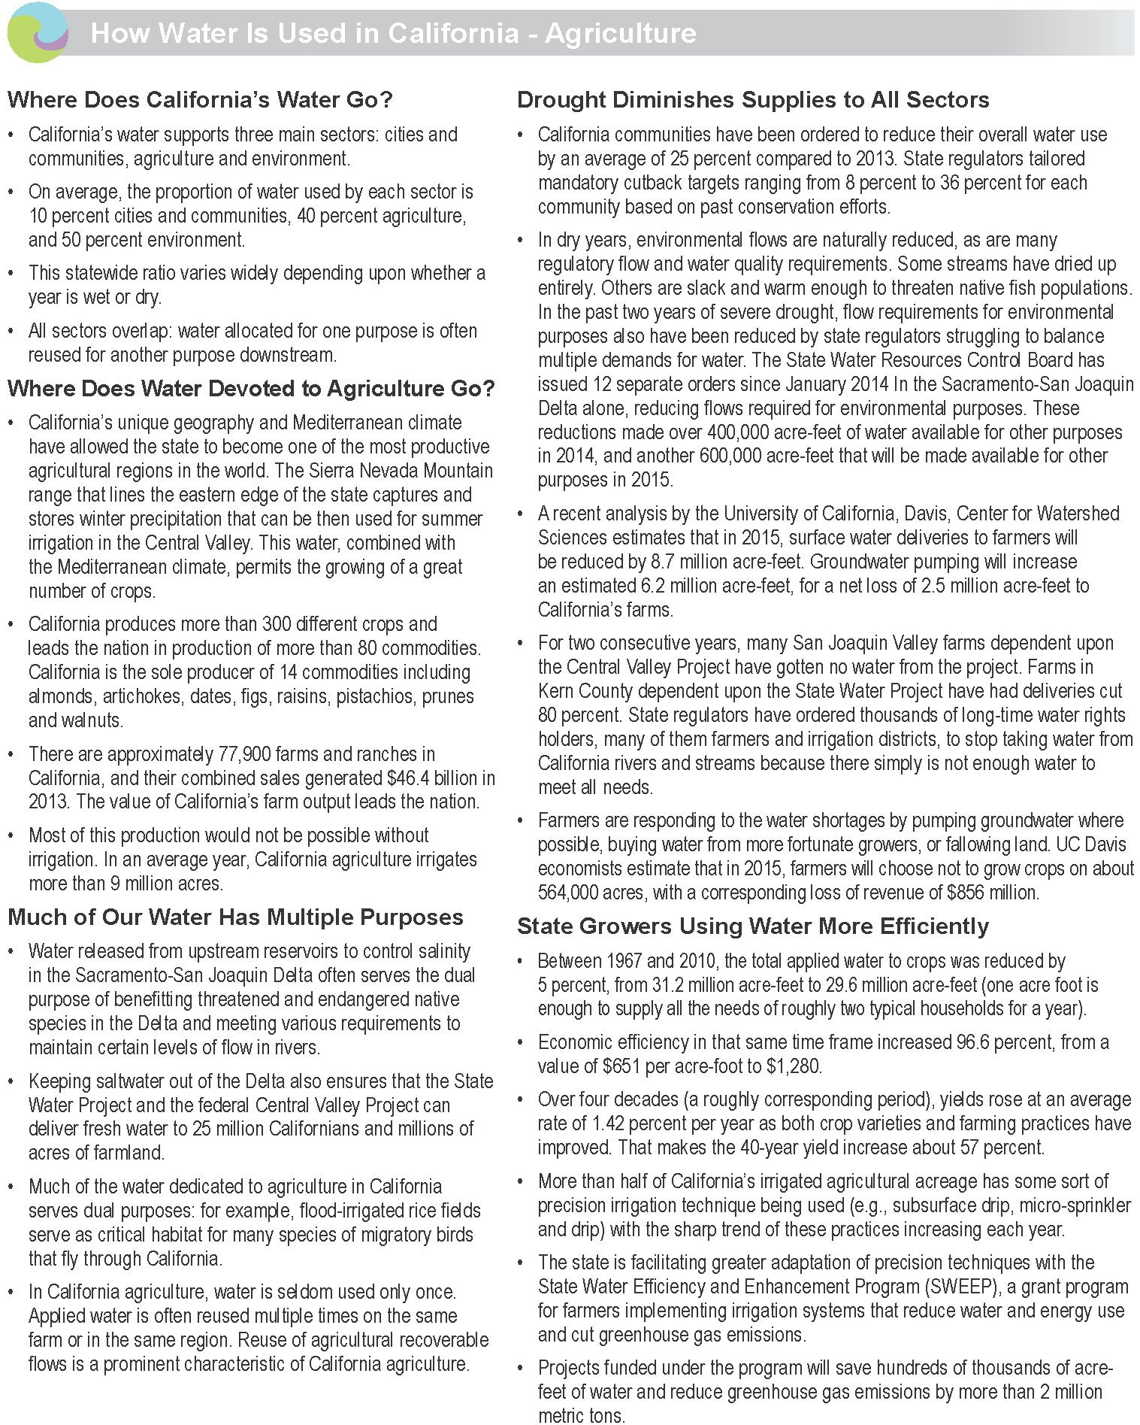
Appendix D: Water Use Fact Sheets (CDWR, 2014)
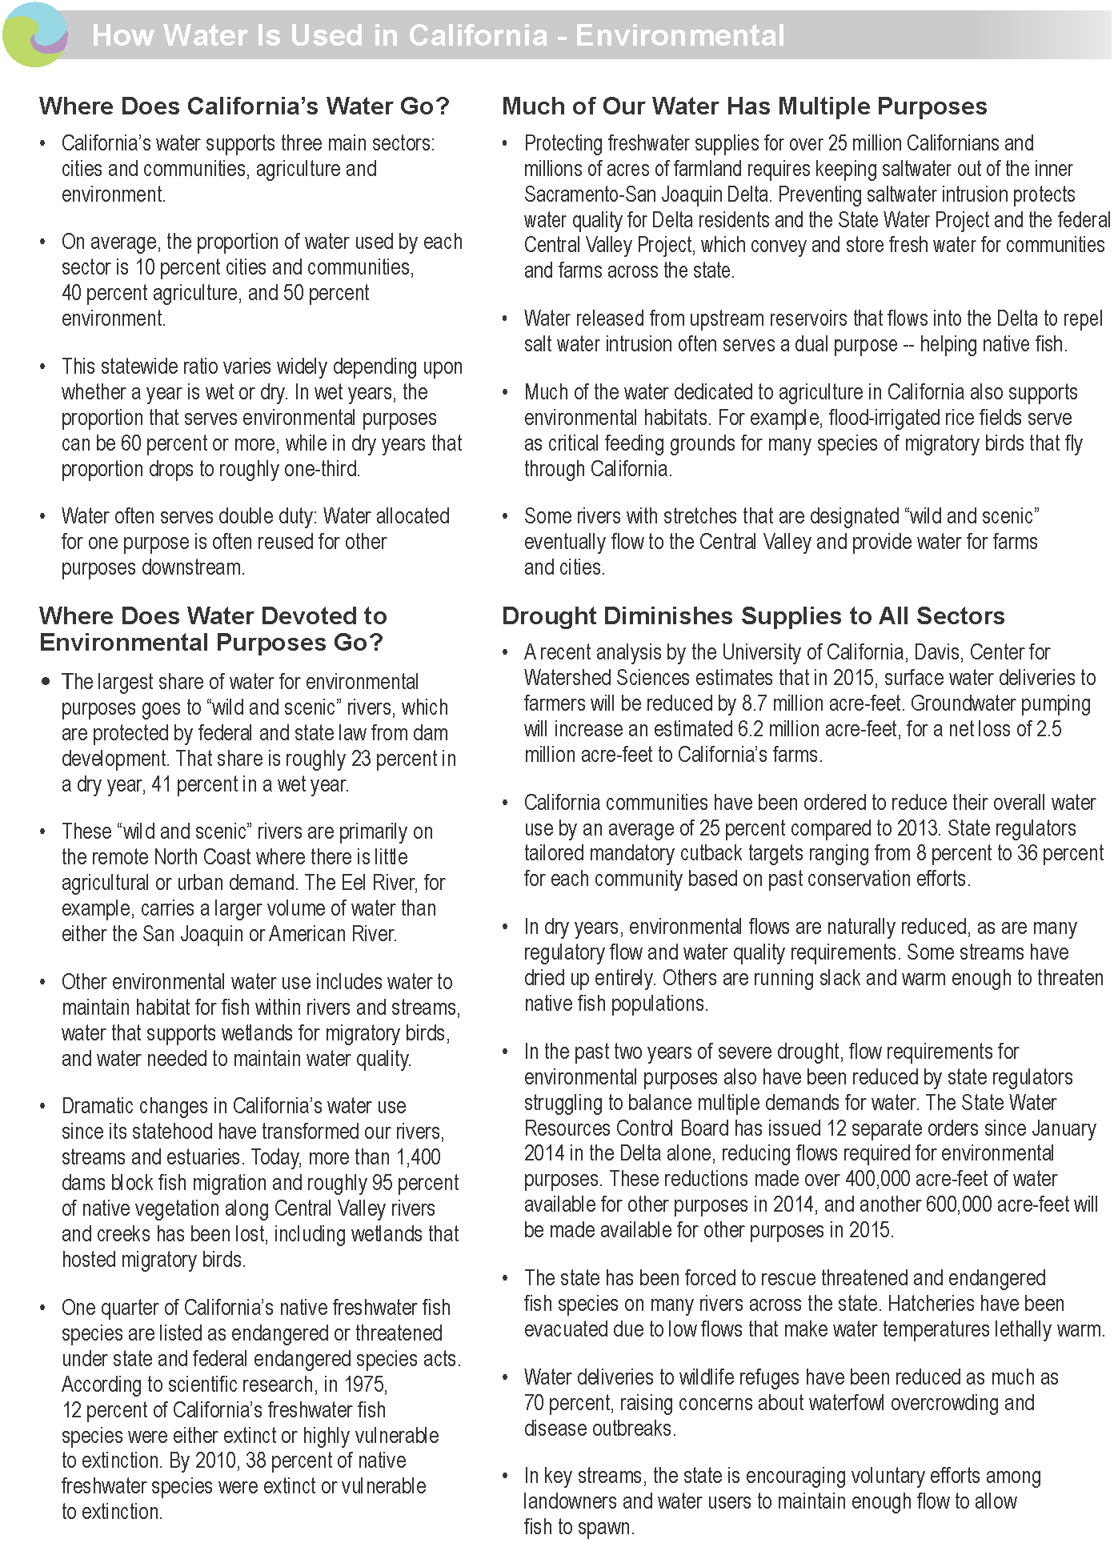
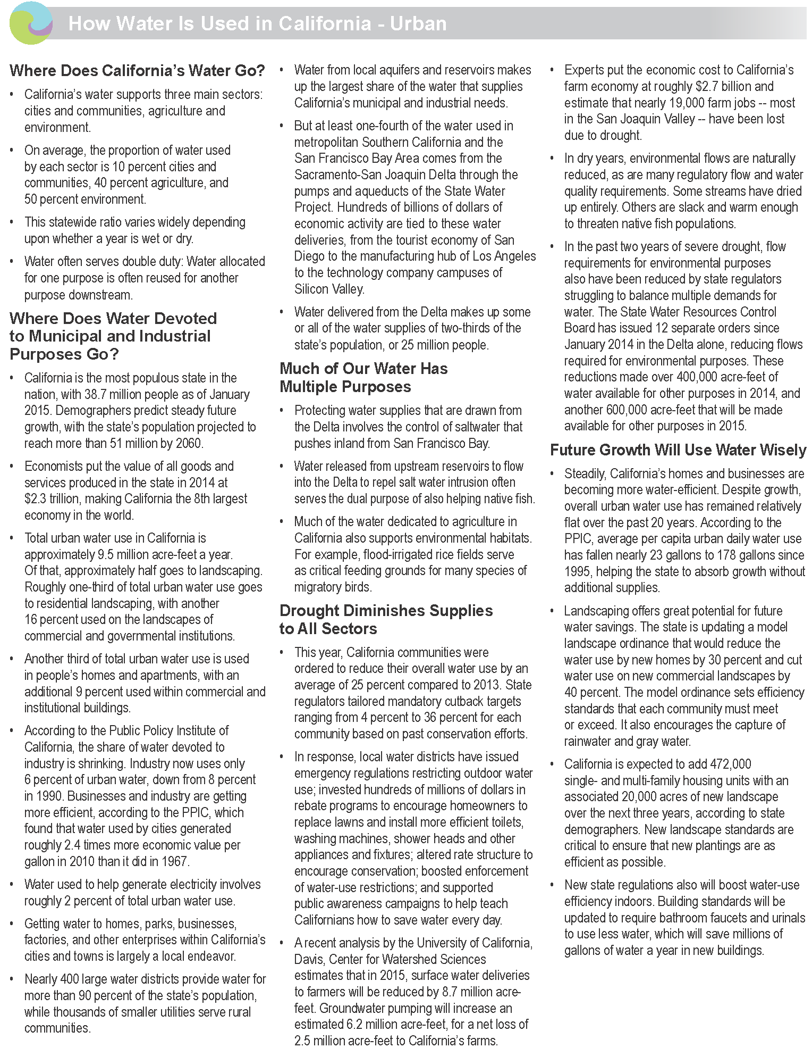

Appendix E: Potential Partners for Collaboration
Please note that the following table does not provide an exhaustive list of potential partners. The organizations listed here were identified through the sector discussions, but the listing does not imply that they have agreed to partner or to implement SWAP 2015.Also note that the table was completed to the best of the team’s knowledge. Where specific organizational efforts or orientations were unknown to the team, corresponding cells were left blank. An asterisk (*) indicates a new opportunity added by CDFW after the team discussions; therefore it was not addressed by the sector team.
Potential Partners | Data Collection and Analysis | Direct Management | Land Acquisition, Easement, and Lease | Law and Policy | Management Planning | Partner Engagement
Association of CA Water Agencies (ACWA)
Audobon CA
Bay Foundation
Bureau of Reclamation
CA Association of Resource Conservation Districts
CA Association of Sanitation Agencies
CA Biodiversity Council (CBC)
CA Climate and Agriculture Coalition Network
CA Coastkeeper Alliance
CA Coastal Conservancy
CA Department of Conservation
CA Department of Fish and Wildlife (CDFW)
CA Department of Food and Agriculture (CDFA)
CA Department of Water Resources (CDWR)
CA Department of Conservation - Division of Oil, Gas and Geothermal Resources (DOGGR)
CA Energy Commission (CEC)
CA EcoRestore
CA Environmental Protection Agency (CalEPA)
CA Lake Management Society
CA Rangeland Conservation Coalition
CA WaterFix
CA Water Plan State Agency Steering Committee
CA Water Quality Monitoring Council
- Bioaccumulation Oversight Group
- CA Wetland Monitoring Working Group
- CA Estuary Monitoring Group
- Healthy Streams (Watershed) Partnership
Central CA Tribal Chairs Association
Central Valley Flood Protection Board
Central Valley Joint Venture
City and County Governments
Delta Conservancy
Delta Stewardship Council
Farm Bureau
Fish Passage Improvement Program and Forum
Flood Control Agencies/Districts
Floodplain Managers Associations
Former Water Plan Groups
Groundwater Ambient Monitoring and Assessment (GAMA) Program
Heal the Bay
Landowners
Local Agency Formation Commission for San Bernardino County (LAFCO)
Mountain Counties Water Resources Association
National Association Lake Management Society (NOMS) California Chapter
NOAA Fisheries
Northern CA Tribal Chairs Association
Open Space Districts
Public Trust Agencies
Point Blue Conservation Science
Resource Conservation Districts (RCDs)
San Francisco Bay Joint Venture
San Francisco Estuary Institute
Santa Ana Watershed Project Authority
Sierra Nevada Conservancy
Southern CA Tribal Chairs Association
Southern CA Wetlands Recovery Project
State Water Resources Control Board (SWRCB)
- Division of Water Rights
- Public Trust Unit
- Surface Water Ambient Monitoring Program (SWAMP)
- Regional Water Quality Control Boards (RWQCBs)
Strategic Growth Council (SGC)
Suisun Resource Conservation District
Surfrider Foundation
The Nature Conservancy (TNC)
Tribal Communities
U.S. Army Corps of Engineers (USACE)
U.S. Fish & Wildlife Service (USFWS)
Waste Water Treatment Plants
Water and Utility Districts
Waterkeeper Alliance
Watershed Authorities
- San Bernardino
- San Gabriel Valley Watershed Authority
Western Riverside County Agricultural Coalition
Wildlife Conservation Board

Appendix F: Potential Financial Resources
Potential Financial Resources  (Note: this information is intended to serve as a starting point for outreach and potential engagement, and does not represent a comprehensive list of all the potential funding sources) | Data Collection and Analysis | Direct Management | Land Acquisition, Easement, and Lease | Law and Policy
CA Department of Fish and Wildlife (CDFW)
Greenhouse Gas Reduction Fund (cap and trade)
In lieu fees
Natural Resources Conservation Service – Environmental Quality Incentives Program (EQIP)
Proposition 1
Small Communities Grant
State Revolving Fund
Storage Grant Program
Supplemental Environmental Projects through Water Board enforcement actions
USEPA Wetland Program Development Grants
Wildlife Conservation Board

Funding sources available to multiple strategy categories:
National Fish and Wildlife Foundation – Five State and Urban Water Restoration Grant Program
NRCS – Environmental Quality Incentives Program
USEPA Wetland Program Development Grants
DWR - Sustainable Groundwater Management Act
      - FloodSAFE Environmental Stewardship and Statewide Resources Office
      - Integrated Regional Water Management Plans (IRWMPs) program
Delta Conservancy
Proposition 1
      - Storage Grant Program
RWQCB grants
Suisun Marsh Plan amendment
Wildlife Conservation Board

Appendix G: Companion Plan Management Team
Name | Title
Armand Gonzales | SWAP 2015 Project Lead, CDFW
Junko Hoshi | SWAP 2015 Assistant Project Lead, CDFW
Kurt Malchow | SWAP 2015 Companion Plan Development Lead, CDFW
Tegan Hoffman | Project Director and Facilitator, Blue Earth Consultants
Sarah Eminhizer | Project Manager and Facilitator, Blue Earth Consultants
Jennifer Lam | Associate, Blue Earth Consultants
Diana Pietri | Associate, Blue Earth Consultants

Appendix H. Glossary
The definitions found here are referenced from SWAP 2015, and are mostly adopted from the glossary in the Conservation Measures Partnership’s (CMP) Open Standards for the Practice of Conservation (Version 2.0). Some terms have been added or refined to clarify their use by CDFW.
activity: a task needed to implement a strategy, and to achieve the objectives and the desirable outcomes of the strategy.
anadromous: refers to fish species that spend most of their lives in the ocean but migrate to freshwater rivers and streams to spawn.
aquatic: growing, living in, or frequenting fresh water, usually open water; compare with wetland.
aquifer: an underground reservoir of water.
bay: a body of water connected to an ocean or lake, formed by an indentation of the shoreline.
bioaccumulation: the uptake and concentration of chemicals by living systems.
biodiversity: the full array of living things.
climate change vulnerability: refers to the degree to which an ecological system, habitat, or individual species is likely to be negatively affected as a result of changes in climate and often dependent on factors such as exposure, sensitivity, and adaptive capacity.
conservation: the use of natural resources in ways such that they may remain viable for future generations. Compare with preservation.
distribution: the pattern of occurrences for a species or habitat throughout the state; generally more precise than range.
ecosystem function: the operational role of ecosystem components, structure, and processes.
ecosystem health: the degree to which a biological community and its nonliving environmental surroundings function within a normal range of variability; the capacity to maintain ecosystems structures, functions, and capabilities to provide for human need.
ecosystem processes: the flow or cycling of energy, materials, and nutrients through space and time.
ecosystem: a natural unit defined by both its living and non-living components; a balanced system for the exchange of nutrients and energy. Compare with habitat.
estuary: an area in which salt water from the ocean mixes with flowing fresh water, usually at the wide mouth of a river.
evaluation: an assessment of a project or program in relation to its own previously stated goals and objectives.
fragmentation: the process by which a contiguous land cover, vegetative community, or habitat is broken into smaller patches within a mosaic of other forms of land use/land cover; e.g., islands of an older forest age class immersed within areas of younger-aged forest, or patches of oak woodlands surrounded by housing development.
goal: a formal statement detailing a desired outcome of a conservation project, such as a desired future status of a target. The scope of a goal is to improve or maintain key ecological attributes. A good goal meets the criteria of being linked to targets, impact oriented, measurable, time limited, and specific.
habitat: where a given plant or animal species meets its requirements for food, cover, and water in both space and time. May or may not coincide with a single macrogroup, i.e., vegetated condition or aquatic condition. Compare with ecosystem.
impact: the desired future state of a conservation target. A goal is a formal statement of the desired impact.
landscape: the traits, patterns, and structure of a specific geographic area, including its biological composition, its physical environment, and its anthropogenic or social patterns. An area where interacting ecosystems are grouped and repeated in similar form.
monitoring: the periodic collection and evaluation of data relative to stated project goals and objectives. Many people often also refer to this process as monitoring and evaluation (abbreviated M&E).
native: naturally occurring in a specified geographic region.
nonpoint: pollution whose source cannot be ascertained, including runoff from storm water and agricultural, range, and forestry operations, as well as dust and air pollution that contaminate waterbodies.
outcome: an improved (and intended) future state of a conservation factor due to implementation of actions or strategies. An objective is a formal statement of the desired outcome.
output: a deliverable that can be measured by the activities and processes that will contribute to accomplishing the desired outcomes and goals.
population: the number of individuals of a particular taxon in a defined area.
pressure: an anthropogenic (human-induced) or natural driver that could result in impacts to the target by changing the ecological conditions. Pressures can be positive or negative depending on intensity, timing, and duration. See also direct pressure and indirect pressure.
private land: lands not publicly owned, including private conservancy lands.
program: a group of projects which together aim to achieve a common broad vision. In the interest of simplicity, this document uses the term “project” to represent both projects and programs since these standards of practice are designed to apply equally well to both.
project: a set of actions undertaken by a defined group of practitioners – including managers, researchers, community members, or other stakeholders – to achieve defined goals and objectives. The basic unit of conservation work. Compare with program.
public: lands owned by local, state, or federal government or special districts.
range: the maximum geographic extent of a taxon or habitat; does not imply that suitable conditions exist throughout the defined limits. Compare with distribution.
rangelands: any expanse of land not fertilized, cultivated, or irrigated that is suitable and predominately used for grazing domestic livestock and wildlife.
result: the desired future state of a target or factor. Results include impacts which are linked to targets and outcomes which are linked to threats and opportunities.
richness: a measure of diversity; the total number of plant taxa, animal species, or vegetation types in a given area.
riparian: relating to rivers or streams.
salmonids: collective term for a family of fish that includes salmon and trout.
Species of Greatest Conservation Need (SGCN): all state and federally listed and candidate species, species for which there is a conservation concern, or species identified as being highly vulnerable to climate change.
stakeholder: any individual, group, or institution that has a vested interest in the natural resources of the project area and/or that potentially will be affected by project activities and have something to gain or lose if conditions change or stay the same. Stakeholders are all those who need to be considered in achieving project goals and whose participation and support are crucial to its success.
strategy: a group of actions with a common focus that work together to reduce pressures, capitalize on opportunities, or restore natural systems. A set of strategies identified under a project is intended, as a whole, to achieve goals, objectives, and other key results addressed under the project.
stress: a degraded ecological condition of a target that resulted directly or indirectly from pressures defined above (e.g., habitat fragmentation).
total maximum daily load (TMDL): a calculation of the maximum amount of a pollutant that a waterbody can receive and still meet water quality standards, as well as an estimation of the percentage originating from each pollution source. A TMDL is the sum of the allowable loads of a single pollutant from all contributing point and nonpoint sources. The calculation must include a margin of safety to ensure that the waterbody can be used for state-designated purposes. The calculation must also account for seasonal variation in water quality.
watershed: defined here as a stream or river basin and the adjacent hills and peaks which "shed," or drain, water into it.
wetland: a general term referring to the transitional zone between aquatic and upland areas. Some wetlands are flooded or saturated only during certain seasons of the year. Vernal pools are one example of a seasonal wetland.
wildlife: all species of free-ranging animals, including but not limited to mammals, birds, fishes, reptiles, amphibians, and invertebrates.

Although the management team sought to engage a broad range of partners, CDFW recognizes that there are many other partners who play important roles in conserving and managing natural resources in California who were not involved in developing the companion plans.
Due to the geographical differences across California, some pressures may not apply to certain regions.

