PS Procedures for Notice of Personnel Action - Probation Memos
- After Keying a new permanent employee, you will receive a NOPA from SCO that outlines the probation dates. See highlighted area below
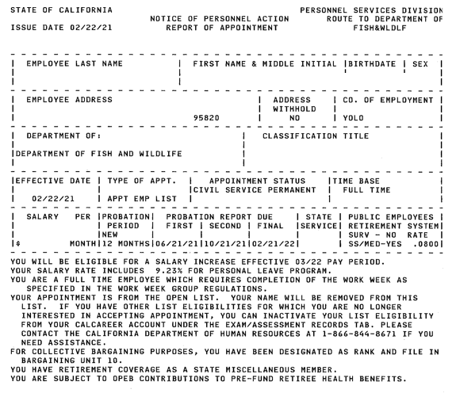

- Please draft a memo using this template. And adding the dates from the highlighted NOPA section of the EE when received.
- Once the memo is drafted, PDF it and email to the supervisor.
  - To find the supervisor you can search HRMS by employee, employee dashboard, search EE name, then you will see supervisor spot
- Drag and drop the email to the supervisor with the attached memo into the OPF filing folder on the shared drive under the folder of the EE last name, see example below.
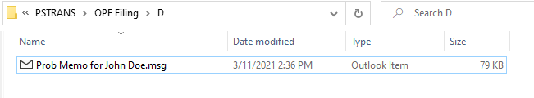
Any additional questions please contact the trainer.

